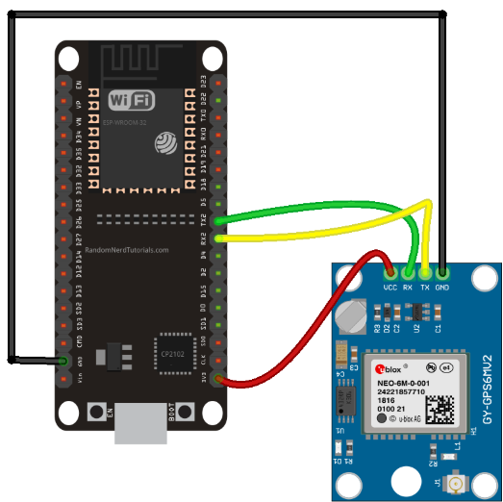

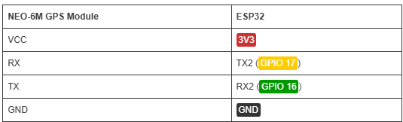

**Code:**

#include <TinyGPS++.h>

// Define the RX and TX pins for Serial 2

#define RXD2 16

#define TXD2 17

#define GPS_BAUD 9600

// The TinyGPS++ object

TinyGPSPlus gps;

// Create an instance of the HardwareSerial class for Serial 2

HardwareSerial gpsSerial(2);

void setup() {

// Serial Monitor

Serial.begin(115200);

// Start Serial 2 with the defined RX and TX pins and a baud rate of 9600

gpsSerial.begin(GPS_BAUD, SERIAL_8N1, RXD2, TXD2);

Serial.println("Serial 2 started at 9600 baud rate");

}

void loop() {

// This sketch displays information every time a new sentence is correctly encoded.

unsigned long start = millis();

while (millis() - start < 1000) {

while (gpsSerial.available() > 0) {

gps.encode(gpsSerial.read());

}

if (gps.location.isUpdated()) {

Serial.print("LAT: ");

Serial.println(gps.location.lat(), 6);

Serial.print("LONG: ");

Serial.println(gps.location.lng(), 6);

Serial.print("SPEED (km/h) = ");

Serial.println(gps.speed.kmph());

Serial.print("ALT (min)= ");

Serial.println(gps.altitude.meters());

Serial.print("HDOP = ");

Serial.println(gps.hdop.value() / 100.0);

Serial.print("Satellites = ");

Serial.println(gps.satellites.value());

Serial.print("Time in UTC: ");

Serial.println(String(gps.date.year()) + "/" + String(gps.date.month()) + "/" + String(gps.date.day()) + "," + String(gps.time.hour()) + ":" + String(gps.time.minute()) + ":" + String(gps.time.second()));

Serial.println("");

}

}

}